
Annexure A

NED UNIVERSITY OF ENGINEERING AND TECHNOLOGY
Centre of Multidisciplinary Postgraduate Programmes (CMPP) Postgraduate Diploma (PGD) Programmes
CONSENT FORM FOR SUPERVISOR
(To be submitted to Focal Person)

To be filled by student

Name of Student: MUHAMMAD USAMA ALAM
PGD in GENERATIVE AI

Batch: 5 FALL I 2025
Project Title: MediScan: A Human-in-the-Loop, Explainable AI Decision-Support System for Prescription Reading and Therapeutically-Equivalent Medicine Substitution
Name of Supervisor: SAJID MAJEED

To be filled by supervisor
Qualification(s) MS Data Science

Experience in relevant field: AI , Machine Learning & Gen AI
Address:

Tel. Res: Office: Cell: 03455405883

I hereby give my consent to supervise above mentioned PGD student with the mentioned title. I assure that I shall abide by the rules as outlined in PGD Programme of NED Academy.

Signature: 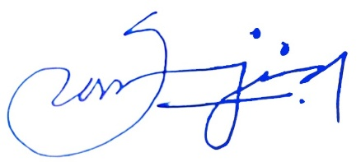

Name: Sajid Majeed
Date: 18/8/2026

